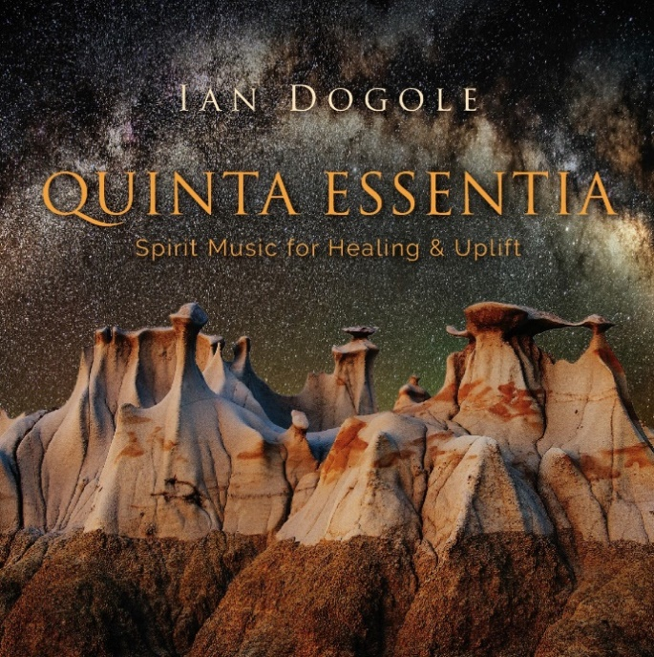
Artist: Ian Dogole

Title: Quinta Essentia

Label: Global Fusion Music

Catalog #: GFM 109876-4

Genre: Jazz/World

Quinta Essentia (Latin for Fifth Essence or Quintessence) is the ninth release from percussionist, composer and bandleader Ian Dogole. Quinta Essentia evokes the presence of an element that transcends the four common physical elements of earth, water, air and fire and exists in its purest form – aether.

Quinta Essentia presents a panoramic view, featuring music that stretches beyond traditional categories. While much of the recording draws inspiration from Jazz luminaries such as John Coltrane, Randy Weston and Wayne Shorter, cross-cultural influences and percussion instruments from Africa, South America, the Middle East and Europe spice up the proceedings throughout.

Jazz Radio Suggestions: Sun Song, United, The Gathering, Togo, Reflections by the Bay (Window)

World Music Radio Suggestions: Nubian Dreams

Unusual Instrument Features: Svoboda, Trane Tracks, Quince y Quatro

Musicians:

- Ian Dogole – djembes, floor tom, hand drum, udu, cajon, African talking drum, hang, kalimba, cymbals, maracas llaneras, Sundrum, shakers, ankle bells, misc. percussion
- Richard Howell – tenor and soprano saxophones, vocals
- Sheldon Brown – tenor and soprano saxophones, bass clarinet
- Fred Randolph – double bass
- Frank Martin – piano, synthesizer
- Yassir Chadly – vocals, gimbri
- Henry Hung – trumpet
- Moses Sedler – cello

Music Beyond Borders 802B Sutro Avenue Novato, CA 94947
ian@iandogole.com 415.383.7120 www.iandogole.com

